Diabetes Quick Tips for NEE primary care
*Please note this is just a ‘handy guide’, refer to full NICE guidance: https://www.nice.org.uk/guidance/ng17 and local ICB guidance: https://tinyurl.com/ytkpm6n2 for full detail*
Suspected newly diagnosed diabetes -
- Refer to WHO/ Diabetes UK for diagnostic criteria: https://bit.ly/31nmS6a
- Main symptoms: polyuria, polydipsia and unexplained weight loss, tiredness, (Think the 4 Ts’ ‘Toilet, Tired, Thirsty, Thinner) UTI/ genital infections, abscess anywhere on body, blurred vision, poor healing wounds.
- If symptomatic, do a same day capillary glucose via finger prick, and ketones (plasma or urinary) urgently. Symptoms plus below are diagnostic of diabetes:
  - a random venous plasma glucose concentration ≥ 11.1 mmol/L or
  - a fasting plasma glucose concentration ≥ 7.0 mmol/L (whole blood ≥ 6.1 mmol/L) or
  - Two-hour plasma glucose concentration ≥ 11.1 mmol/L two hours after 75g anhydrous glucose in an oral glucose tolerance test (OGTT)- used mainly in suspected Gestational Diabetes.
If symptomatic do NOT test just HbA1c, same day action is required as above. If not symptomatic and clinically well HbA1c can be used as below.
  - HbA1c of 48mmol/mol is the cut off for diagnosis diabetes, but without symptoms cannot be used as a standalone tool.
Also, situations where HbA1c is not appropriate for diagnosis of diabetes:
  - ALL children and young people <19yrs of age
  - patients of any age suspected of having Type 1 diabetes (symptoms detailed above)
  - patients with symptoms of diabetes for less than 2 months
  - patients at high risk who are acutely ill (e.g. those requiring hospital admission)
  - patients with acute pancreatic damage, including pancreatic surgery
  - in pregnancy
  - presence of genetic, haematologic and illness-related factors that influence HbA1c and its measurement (see annex 1 of the WHO report for a list of factors which influence HbA1c and its measurement)
- Hyperglycaemia - blood glucose levels higher than 15mmol/L or of concern & needing quick action.
  - Check if blood test accurate (e.g. not directly post large meal, hands washed, and blood strips in date and stored correctly (not been kept in a car etc), home glucose meter < 2years old). If using flash glucose/ continuous glucose monitor (CGM), high reading should be verified with a finger prick blood glucose.
  - Consider causes (larger take away meal, sugary drink, less active, stress, illness, side effect from Covid or flu vaccine, new course of steroids?). Is this a one-off cause or likely to continue?
  - Check blood ketone levels (urine acceptable if no access to blood) 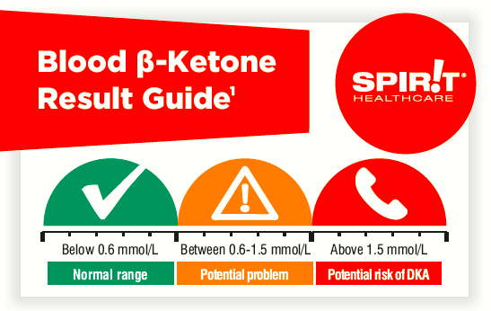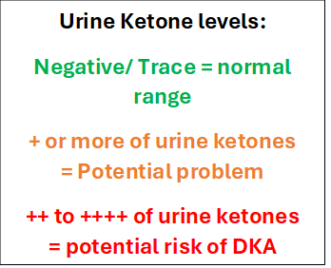
If suspected new Type 1 patient will require urgent referral to NEEDS on call or main office 0345 241 3313. If newly diagnosed patient is not picked up in practice until after NEEDS hours (after 4.30pm or at the weekend/ BH) please consider below to decide next steps:

Guidelines for suspected new type 1 diabetes diagnosed outside of NEEDS hours (If during 8.30-4.30 Mon-Fri please call NEEDS team direct).
Clinically Unwell
Abnormal Obs, looks unwell, reports to feel unwell.
And/ Or
Any sign or symptom of impending or active DKA:
- Stomach pain
- Nausea / Vomiting
- Unable to keep fluids down
- Extreme thirst
- Extreme tiredness
- Confusion
- Pear drops smelling breath
- Altered breathing
- Dehydration
Clinically Well
Obs normal (except glucose and ketones)
No signs of DKA
Patient reports to feel well in themselves

Ketones Moderate - Low (<1.5mmol/L blood / + or nil urine)

If able do an insulin start in practice + give safety netting + refer to NEEDS next working day
(refer to ICB insulin guidance & diabetes UK website if required)
**Ensure pharmacy has insulin in stock & patient starts same day**

Ketones Very High – High (1.5mmol/L + blood / ++ or above urine)

Refer direct to local A&E for urgent care & make referral to NEEDS to flag

Provide safety netting guidance & refer to NEEDS within 24hours / next working day as urgent.
If only a mild or minimal symptoms above & patient safe, consider if appropriate to manage in community with specialist team> still urgent & provide with safety netting guidance.

Safety netting:
- Provide a blood & ketone meter, show how to use and advise to start testing glucose pre meals and pre bed, and ketones if glucose >15mmol/L and/ or if feels unwell
- Advise of signs & symptoms of DKA, if any occur or ketone test >1.5mmol/L to attend A&E urgently
- If symptoms become worse or they are worried attend A&E or call 111.
- Aim to rest and keep hydrated until reviewed
- Provide diabetes UK website www.diabetes.org.uk for reading online
- Advise not to have any sugary drinks including fruit juice, or eat excessive carbohydrates or sugar until seen (their normal 3 meals per day with small snacks if needed and sugar free drinks is fine)

